

Windows Workflow Foundation

Hands-On Lab

Lab Manual
Lab 07 – Creating Rules Driven Workflows

Converted from C# to Visual Basic.NET courtesy of:

Serge Luca – MVP – serge@u2u.be
U2U Training and Consultancy Services is a Microsoft .NET competence center located in Belgium, to learn more please visit www.u2u.be

Information in this document, including URL and other Internet Web site references, is subject to change without notice. This document supports a preliminary release of software that may be changed substantially prior to final commercial release, and is the proprietary information of Microsoft Corporation.

This document is for informational purposes only. MICROSOFT MAKES NO WARRANTIES, EITHER EXPRESS OR IMPLIED, AS TO THE INFORMATION IN THIS DOCUMENT.

The entire risk of the use or the results from the use of this document remains with the user. Complying with all applicable copyright laws is the responsibility of the user. Without limiting the rights under copyright, no part of this document may be reproduced, stored in or introduced into a retrieval system, or transmitted in any form or by any means (electronic, mechanical, photocopying, recording, or otherwise), or for any purpose, without the express written permission of Microsoft Corporation.

Microsoft may have patents, patent applications, trademarks, copyrights, or other intellectual property rights covering subject matter in this document. Except as expressly provided in any written license agreement from Microsoft, the furnishing of this document does not give you any license to these patents, trademarks, copyrights, or other intellectual property.

Unless otherwise noted, the example companies, organizations, products, domain names, e-mail addresses, logos, people, places and events depicted herein are fictitious, and no association with any real company, organization, product, domain name, email address, logo, person, place or event is intended or should be inferred.

© 2007 Microsoft Corporation. All rights reserved.

Microsoft, MS-DOS, Windows, Windows NT, Windows Server, Visual C# and Visual Studio are either registered trademarks or trademarks of Microsoft Corporation in the United States and/or other countries.

The names of actual companies and products mentioned herein may be the trademarks of their respective owners.

Contents
Lab 07: Creating Rules Driven Workflows 1
Lab Objective 1
Exercise 1 – Using the ConditionedActivityGroup Activity 1
Task 1 – Create a new Sequential Workflow Console Application 1
Task 2 – Add the ConditionedActivityGroup and Code activities 2
Task 3 – Define the conditions 7
Task 4 – Run the workflow 10
Exercise 2 – Using the Replicator Activity 11
Task 1 – Create a new Sequential Workflow Console Application 11
Task 2 – Add the Replicator 12
Task 3 – Run the workflow 16
Exercise 3 – Using the Policy Activity 18
Task 1 – Create a new Sequential Workflow Console Application 18
Task 2 – Add and configure a PolicyActivity 19
Task 3 – Run the workflow 21
Lab Summary 23

Lab 07: Creating Rules Driven Workflows
Estimated time to complete this lab: 45 minutes
The project files for this lab are in the c:\Windows Workflow Foundation\Labs\VB\Lab07 folder.

Lab Objective
The objective of this lab is to introduce several of the more advanced activities provided with Windows Workflow Foundation. After completing this lab, you will be able to:
- Use the ConditionedActivityGroup activity.
The ConditionedActivityGroup activity allows you to provide condition-driven execution behavior to a collection of activities. This behavior allows you to define the condition under which a given activity will execute, as opposed to defining a strict sequencing or flow of activity execution.

- Use the Replicator activity to launch multiple copies of other activities.
The Replicator activity allows you to dynamically generate multiple instances of an activity based on the data provided in a collection at runtime. The instances can be created in sequential or parallel fashion.

- Use a Policy based activity to implement application logic
The Policy activity encapsulates a forward chaining rules engine. Creating a custom activity that inherits from the Policy activity allows you to define sophisticated application logic that is then available for use in your workflows.

Exercise 1 – Using the ConditionedActivityGroup Activity
In this exercise you will create a simple console application to instantiate the Windows Workflow Foundation runtime and start a ConditionedActivityGroup based workflow.

Task 1 – Create a new Sequential Workflow Console Application
- Open Visual Studio 2005 by going to the Start Menu | Programs | Microsoft Visual Studio 2005 | Microsoft Visual Studio 2005
- In Visual Studio 2005, select the File | New | Project menu command.
- Visual Studio will display the New Project dialog window.
- In the New Project dialog window, expand Visual Basic | Workflow in the Project Types tree on the left side.
- Select the template named Sequential Workflow Console Application and accept the default name for the project but change the location to C:\Windows Workflow Foundation\Labs\VB\Lab07\Exercise 1 and leave the Create directory for solution box checked. This will create a subdirectory to C:\Windows Workflow Foundation\Labs\VB\Lab07\Exercise1 and place the project and solution files there. The directory will be named WorkflowConsoleApplication1.

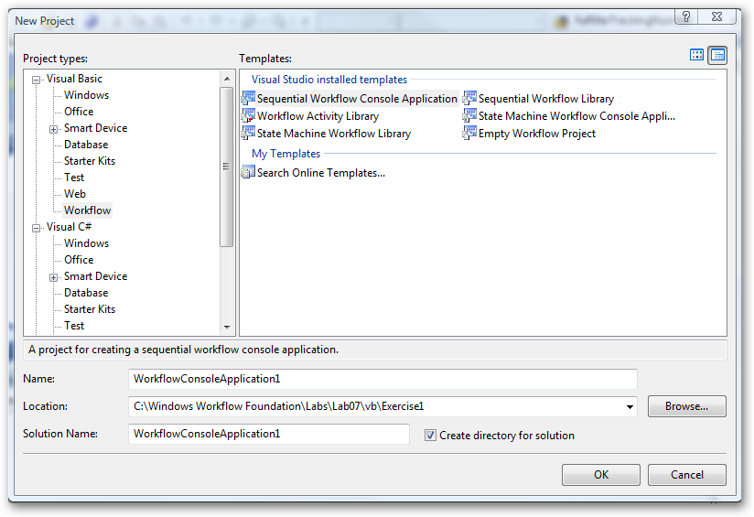

- Click OK and the basic project will be generated.

Task 2 – Add the ConditionedActivityGroup and Code activities
- Let's start by adding some activities to the workflow. First drag and drop a ConditionedActivityGroup activity onto the workflow from the toolbox (select View | Toolbox from the menu if the toolbox is not shown). It should look like this:

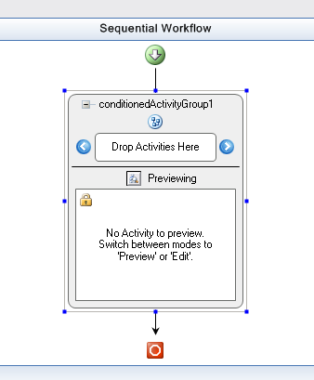

- Now we need to add two Code activities to the ConditionedActivityGroup. In the screen shot above you can see a section of the ConditionedActivityGroup activity that has the words Drop Activities Here. Drag a Code activity from the toolbox to that area and you should see this:

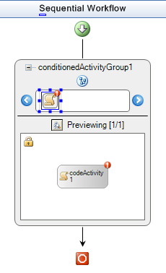

- The little red circles with exclamation marks are an indication that we have not yet connected the Code activity for codeActivity1 to an event handler. We will do that next, but first add another Code activity so that your workflow design looks like this:

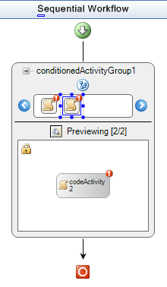
- Next we will add the code handlers for the two Code activities that were added. Place the code below within the Workflow1 class in Workflow1.vb. You can go to Workflow1.vb by right clicking on the design surface and choose View Code.

(Code snippet: “Lab07 Ex01 Task02 CodeHandlers”)
Public Enum NumberIs
Odd = 0
Even = 1
End Enum
Private currentNumber As NumberIs = NumberIs.Even
Private userRequestsExit As Boolean

'number entered is odd
Public Sub codeActivity1_ExecuteCode(ByVal sender As Object, ByVal e As EventArgs)

Console.WriteLine("the number is odd")
GetNextNumber()

End Sub

'number entered is even
Public Sub codeActivity2_ExecuteCode(ByVal sender As Object, ByVal e As EventArgs)

Console.WriteLine("the number is even")
GetNextNumber()
End Sub

'evaluate number entered by user and set currentNumber variable
Private Sub GetNextNumber()

Dim numIn As Integer

Console.WriteLine("enter a number.")
Dim charIn As String = Console.ReadLine()

If Int32.TryParse(charIn, numIn) Then

If ((numIn Mod 2) = 0) Then

currentNumber = NumberIs.Even

Else

currentNumber = NumberIs.Odd
End If

ElseIf (charIn.Contains("x")) Then

userRequestsExit = True

Else

GetNextNumber()
End If
End Sub

- Change back to the designer window.
- Right click on the ConditionedActivityGroup activity and choose Edit Activity from the context menu. You can now select each of the code activities within the ConditionedActivityGroup so that their properties can be set.
- Go to the property window for codeActivity1. It should look like this;

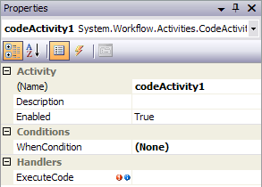

- Click on the ExecuteCode property in the Handlers section. The drop down list should contain the codeActivity1_ExecuteCode and codeActivity2_ExecuteCode methods that we just added.
- Select codeActivity1_ExecuteCode. It should look like this:

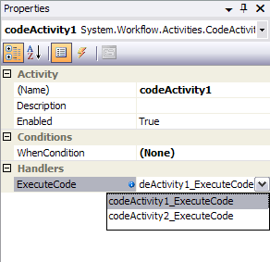

- You can see that there is a red circle with an exclamation mark next to codeActivity2. Now you can click on the codeActivity2 activity and connect its ExecuteCode handler to codeActivity2_ExecuteCode. It should look like this when you are done:

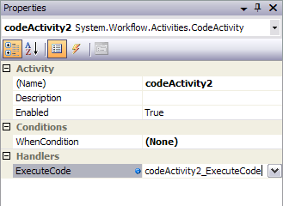

Task 3 – Define the conditions

The next step is to write the functions that will be called when codeActivity1 and codeActivity2's WhenCondition is evaluated. The activity will execute if the WhenCondition evaluates to true. There is also an UntilCondition for the ConditionedActivityGroup activity. If the ConditionedActivityGroup UntilCondition returns true then the ConditionedActivityGroup is finished and it exits.

This example has a very simple scenario. The user is asked to enter a number. That number is evaluated as to whether it is even or odd. If it is odd then currentNumber is set to NumberIs.Odd. If it is even then currentNumber is set to NumberIs.Even. The UntilCondition method bases its return value on the state of the currentNumber variable. If the user types an 'x' then userRequestsExist is set to true, in which case both the UntilCondition evaluates to true and the ConditionedActivityGroup exits.

- Right click on the Workflow1.vb file and select View Code.
- Place the following 3 functions within the Workflow1 class: oddCondition, evenCondition and timeToExit

(snippet: “Lab07 Ex01 Task03 CodeConditions”).

'used to control execution of codeActivity1_ExecuteCode1
Public Sub oddCondition(ByVal sender As Object, ByVal args As _
ConditionalEventArgs)

args.Result = ((currentNumber = NumberIs.Odd))

End Sub

'used to control execution of codeActivity2_ExecuteCode1
Public Sub evenCondition(ByVal sender As Object, ByVal args As _
ConditionalEventArgs)

args.Result = ((currentNumber = NumberIs.Even))

End Sub

'used to control execution of the ConditionedActivityGroup
Public Sub timeToExit(ByVal sender As Object, ByVal args As _
ConditionalEventArgs)

args.Result = userRequestsExit

End Sub

- You should now connect these functions to the corresponding condition handlers so switch back to the designer.
- Click on the conditionedActivityGroup1 activity.
- In the properties window, the UntilCondition for the conditionedActivityGroup1 will read (None).

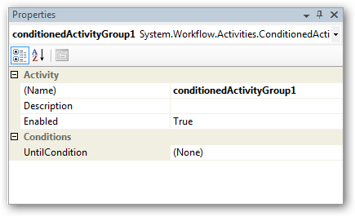

- Click on the down arrow and select System.Workflow.Activities.CodeCondition. Now you can expand this property section by clicking on the plus sign to the left of UntilCondition. When it expands you will see the Condition property just below UntilCondition.

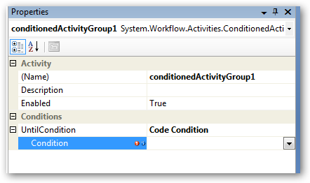

- Click on the drop down and you should see a list of functions to choose from. Select timeToExit. You should see this when you click the drop down:

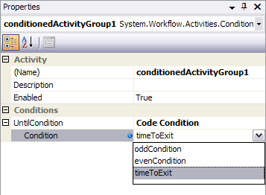

- Now when this workflow runs the UntilCondition of the conditionedActivityGroup1 is evaluated. The conditionedActivityGroup1 will continue to execute as long as the UntilCondition evaluates to false.
- The WhenCondition of codeActivity1 will be set to the oddCondition handler and the WhenCondition of codeActivity2 will be set to the evenCondition handler- we’ll do this in a similar fashion to the way in which we set the CodeCondition above. As the name suggests, codeActivity1 will execute when an odd number is passed in, and codeActivity2 will execute when an even number is passed in.
- Connect the WhenCondition for codeActivity1. The properties window for codeActivity1 will look like this:

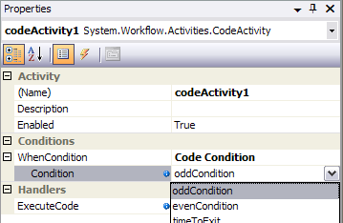

- Connect the WhenCondition for codeActivity2. It should look like this:

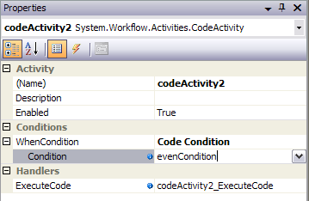

Task 4 – Run the workflow

When you run the application, you can enter numbers and the ConditionedActivityGroup will run the correct code handler based on whether you entered an even or an odd number. When you want to exit type a lower case "x". When you type "x" the timeToExit function returns true and the workflow exits returning execution to the caller. In this case we return to Main, the WorkflowCompleted function is called, we signal our event and Main exits. For simplicity we set currentNumber = NumberIs.Even so the first time through the assumption is that the number is even and we will print out the number is even although you have not typed a number yet.

- We haven't added any code to Module1.vb yet but we need to add the following code highlighted in gray to the end of the Main method- just after the WaitOne call on the waitHandle.
waitHandle.WaitOne()
Console.WriteLine("All done, workflow finished. Press Enter to exit.")
Console.Read()
End Sub

- Now you should be able to compile and run the application by pressing F5 or Ctrl-F5. Try entering some numbers and then type ‘x’ to finish the workflow. You should see something like this:

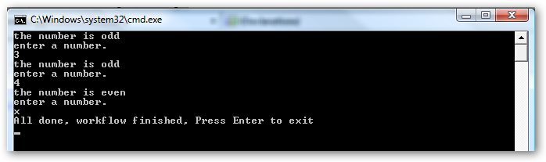

Exercise 2 – Using the Replicator Activity
The Replicator activity can be used to launch multiple copies of other activities. In this example, for simplicity, we will launch copies of a Code activity.

Task 1 – Create a new Sequential Workflow Console Application
- Open Visual Studio 2005 by going to the Start Menu | Programs | Microsoft Visual Studio | Microsoft Visual Studio 2005
- In Visual Studio 2005, select the File | New | Project menu command.
- Visual Studio will display the New Project dialog window.
- In the New Project dialog window, expand Visual Basic| Workflow in the Project Types tree on the left side.
- Select the template named Sequential Workflow Console Application and accept the default name for the project but change the location to C:\Windows Workflow Foundation\Labs\VB\Lab07\Exercise2 and leave the Create directory for solution box checked. This will create a subdirectory to C:\Windows Workflow Foundation\Labs\VB\Lab07\Exercise2 and place the project and solution files there. The directory will be named WorkflowConsoleApplication1.
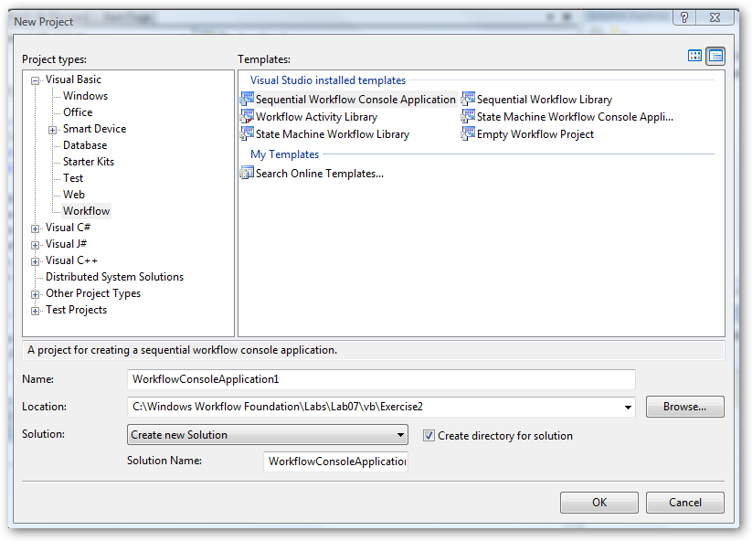

- You should now have a new solution and workflow console application project. The project generated for you will contain 2 files of interest to us. Module1.vb which contains the Main method and the workflow is contained in Workflow1.vb.

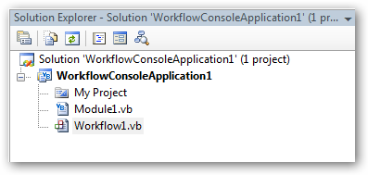

Task 2 – Add the Replicator
- Let's start with the workflow. Add a Replicator activity to your workflow and add a Code activity into the Replicator activity. Your drawing surface should look like the following picture. The little red circles with the exclamation marks indicate that we have not yet fully configured the activities.

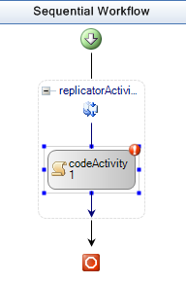

- To connect the handlers and get rid of the little red circles with exclamation marks let's start with the replicator's Initialized handler.
- Switch to the code view of the workflow by right clicking on Workflow1.vb in the solution explorer and choosing View Code.
- Add the following code to Workflow1.vb within the workflow1 class declaration.

(snippet: “Lab07 Ex02 Task02 InitializedHandler”):

Public Sub replicatorActivity1_Initialized(ByVal sender As Object, _
ByVal e As EventArgs)

' Populate the data used for each instance of the Replicator's
' child instance that are created
Dim children As ArrayList = New ArrayList()
children.Add("Child Instance 1")
children.Add("Child Instance 2")
children.Add("Child Instance 3")
children.Add("Child Instance 4")
children.Add("Child Instance 5")
children.Add("Child Instance 6")
replicatorActivity1.InitialChildData = children

' Specify how the child instances should be created - in parallel
' or in a sequence
replicatorActivity1.ExecutionType = ExecutionType.Parallel

End Sub

- This code adds 6 children to the ArrayList which we then assign to replicatorActivity1’s InitialChildData property. We also specify that the ExecutionType is ExecutionType.Parallel. We could have specified ExecutionType.Sequence. You could try both to see the difference- the main difference is that Sequence means that each child will finish executing before the next one starts. You can add more children to the list if you like. The number of Code activities launched is based on the number of children added to the ArrayList children.
- Switch back to design view and connect the Initialized handler to the replicator in replicatorActivity1's property window.
- When you click on the drop down arrow you should see replicatorActivity1_Initialized, click on it to set the Initialized handler.

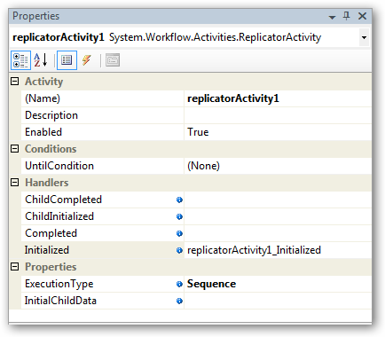

- Next we need to hook up the Code activity's code handler. Add the following code to Workflow1.vb within the Workflow1 class.

(snippet: “Lab07 Ex02 Task02 ExecuteCode”):

Private Sub codeActivity1_ExecuteCode(ByVal sender As System.Object,
_ByVal e As System.EventArgs)
Console.WriteLine("In codeActivity1_ExecuteCode")
End Sub

Back in design view click on the Code activity and then click on its ExecuteCode handler. You should see codeActivity1_ExecuteCode in the properties dropdown. Select that and the handler is connected. It should look like this when you are done.

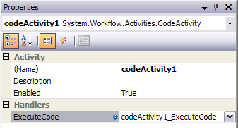

- The Replicator has 2 more code handlers that we want to hook up: ChildCompleted and ChildInitialized. Add the following to Workflow1.vb within the Workflow1 class.

(snippet: “Lab07 Ex02 Task02 ChildEvents”)
Private Sub childCompleted(ByVal sender As Object, _
ByVal e As ReplicatorChildEventArgs)
Console.WriteLine("Completed {0}", e.InstanceData.ToString())
End Sub

Private Sub childInitialized(ByVal sender As Object, _
ByVal e As ReplicatorChildEventArgs)
Console.WriteLine("Initialized {0}", e.InstanceData.ToString())
End Sub

- Connect ChildInitialized to childInitialized and ChildCompleted to childCompleted on the Replicator's handler section. It should look like this:

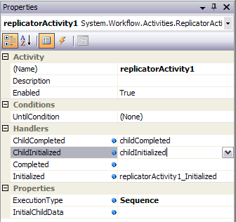

- The workflow itself has a handler we want to hook into. Add this function to the others within the Workflow1 class in the Workflow1.vb file.

(snippet: “Lab07 Ex02 Task02 WorkflowCompleted”).
Private Sub WorkflowCompleted(ByVal sender As System.Object, _
ByVal e As System.EventArgs)
Console.WriteLine("Workflow finished")
End Sub

- Click anywhere outside of the replicator activity on the drawing surface, or select Workflow1 from the combo box in the properties window. Click on the Completed handler for Workflow1 in the properties window and select workflowCompleted.

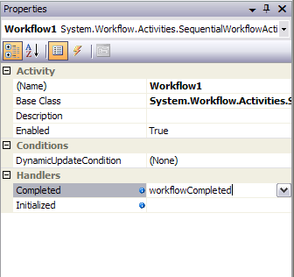

Task 3 – Run the workflow
- Now we have just a minor change to make to Main in the Module1.vb file. Add the following code highlighted in gray to the end of the Main method- just after the WaitOne call.
waitHandle.WaitOne()
Console.WriteLine("Back in Main, press any key to exit.")
Console.Read()
}

- At this point you should be able to compile and run the project you should see the following:

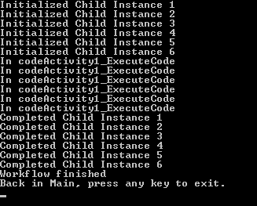

- Change the code in Workflow1.vb as follows:
from
replicatorActivity1.ExecutionType = ExecutionType.Parallel;
to
replicatorActivity1.ExecutionType = ExecutionType.Sequence;

- You will see something like the following:

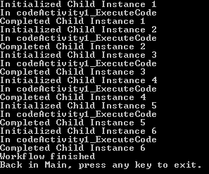

Exercise 3 – Using the Policy Activity
In this exercise you will create a simple console application to instantiate the Windows Workflow Foundation runtime and start a workflow with a Policy based activity.

Task 1 – Create a new Sequential Workflow Console Application
- Open Visual Studio 2005 by going to the Start Menu | Programs | Microsoft Visual Studio 2005 | Microsoft Visual Studio 2005
- In Visual Studio 2005, select the File | New | Project menu command.
- Visual Studio will display the New Project dialog window.
- In the New Project dialog window, expand Visual Basic | Workflow in the Project Types tree on the left side.
- Select the template named Sequential Workflow Console Application and accept the default name for the project but change the location to C:\Windows Workflow Foundation\Labs\VB\Lab07\Exercise3 and leave the Create directory for solution box checked. This will create a subdirectory to C:\Windows Workflow Foundation\Labs\VB\Lab07\Exercise3 and place the project and solution files there. The directory will be named WorkflowConsoleApplication1.
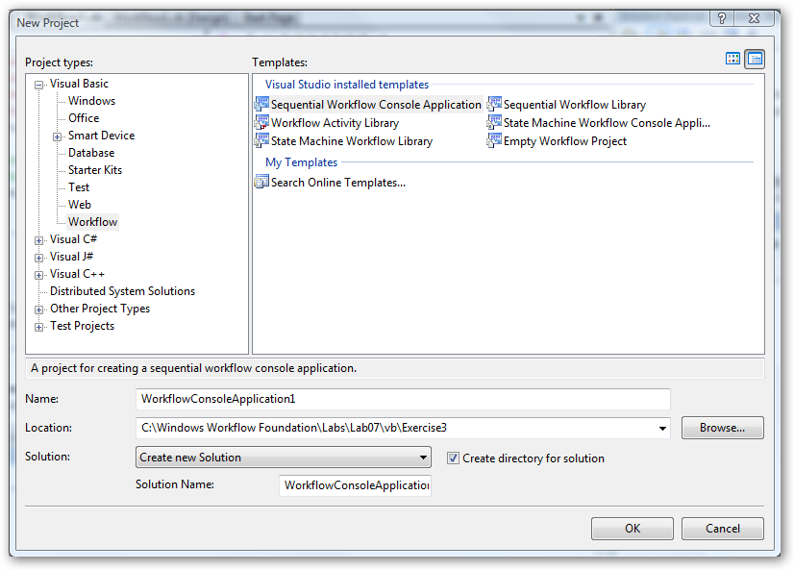

- Click OK and the basic project will be generated.

Task 2 – Add and configure a PolicyActivity

- Right-click on Workflow1.vb in the Solution Explorer and select View Code.
- Add the following lines to the beginning of the Workflow1 class declaration. These are the parameters that our PolicyActivity will use:

Public orderValue As Int32 = 600
Public discount As Int32

- Go to the designer view for Workflow1.vb. You can do this by right-clicking on it in the Solution Explorer and selecting View Designer.
- Add a Policy activity to the workflow. It should now look like this:

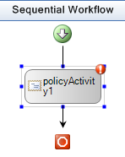
- In the properties window click on the ellipses next to the RuleSetReference property of policyActivity1.
- The Select RuleSet dialog will appear. Click the New RuleSet… button as shown below:

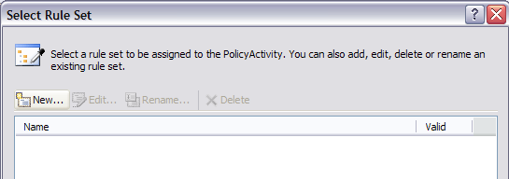

- This will bring up a new dialog, Rule Set Editor. Click Add Rule and enter the values for the lower three editable regions shown in the image below:

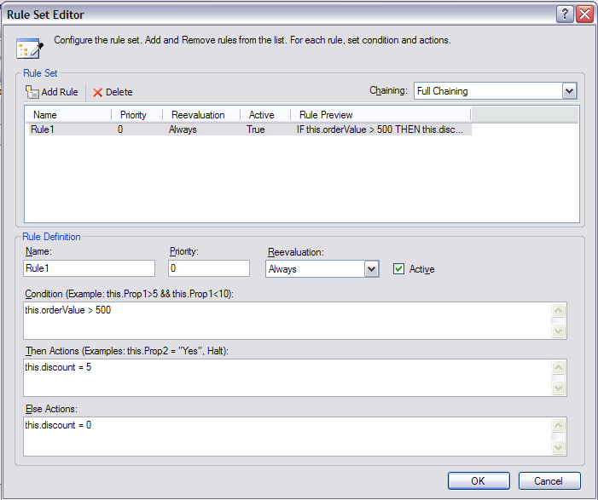

- Click OK then OK again to set the rules for the policy. Notice that a file called Workflow1.rules has been added to your solution (shown below). This file contains an XML definition of any rules and rule sets for Workflow1.

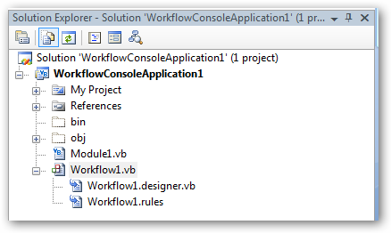

- Select the outer SequentialWorkflow and in the Properties window set the Completed handler to WorkflowCompleted and hit Enter to go to the Workflow1.vb code (or right click on the workflow and select View Code). Add the following code to the handler:
Private Sub WorkflowCompleted(ByVal sender As System.Object, _
ByVal e As System.EventArgs)
Console.WriteLine("OrderValue = {0}", this.orderValue)
Console.WriteLine("Discount = {0}", this.discount)

End Sub

Task 3 – Run the workflow
- Now we have just a minor change to make to Main in the Module1.vb file. Add the two lines of code highlighted in gray at the end of the Main method, just after the call to WaitOne:
workflowInstance.Start()

waitHandle.WaitOne()
Console.WriteLine("Back in Main, press Enter to exit.")
Console.Read()
}

- You should now be able to compile and run the application. After pressing Ctrl-F5, you should see something like this:

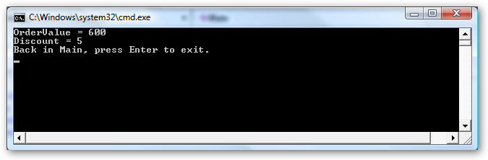

- If you change the orderValue (set in task 2, step 2) in Workflow1.vb to less than 500 and re-compile and run the application you will see something like:
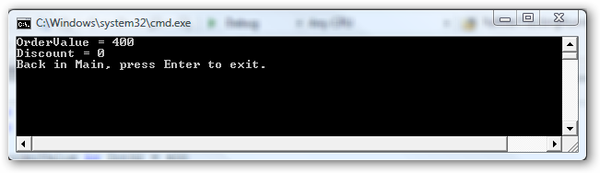

Lab Summary
The objective of this lab has been to introduce several of the advanced built in Activities provided with Windows Workflow Foundation. You should know how to use:
- The ConditionedActivityGroup activity to provide condition-driven behavior to an activity set.
- The Replicator activity to launch multiple copies of another activity.
- A Policy based activity to implement application logic.

